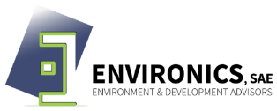

Waste
(WS01)

Fact Sheet WS01: Examine the major sources of wastes by performing a waste audit
Overview
Objective | - To understand the different types of waste produced, such as paper, cardboard, glass, plastics, metals, food etc. to establish a baseline to compare progress against objectives and targets  - To identify the Waste generation sources in the facility  - To Identify the quantity and type of the waste generated from the facility
Action | - Identify the waste sources in the facility  - Calculate your total waste volume and weight  - Identify where waste is created  - Conduct a waste audit
Key Challenges | - Lack of knowledge on how to identify the waste sources and type  - Data unavailability
Regulatory Aspects | None
Process
Complexity | Low to Moderate
Equipment & Material | None
Human Resources | HSE
Considerations
Advantages | - Better understanding of the waste generated from the facility  - Help in analyzing and selecting the most technical and feasible recycling alternative  - Better planning for waste management
Disadvantages | - Might need contracting an expert for waste characterization (In case of the insufficiency of experience of the current staff)  - Documentation and auditing activities
Impact/Benefits
Environmental | Support developing appropriate action plans, and selecting low cost actions
Employment Opportunities | Moderate (depends on availability of staff)

