Waste and Waste Water
(WT03)
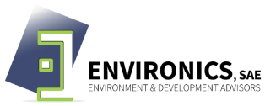

Fact Sheet WT03: Purchase industrial dishwashers and laundry machines, and not conventional domestic appliances.
Overview
Objective | To decrease water consumption
Action | Purchase industrial dishwashers and laundry machines
Key Challenges | Substitute all domestic appliances with industrial machines
Process
Complexity | Low – industrial machines available in the market
Equipment & Material | Industrial dishwasher and industrial laundry machines
Human Resources | Technicians
Considerations
Regulatory Aspects | None
Economic | Moderate CAPEX, Low OPEX, High savings, Moderate payback
Advantages | - Decreased time of process in the kitchen and the laundry  - Increased efficiency  - Decreased fresh water consumption
Disadvantages | Increase in electricity consumption
Impacts
Environmental | Decrease fresh water consumption in kitchen and laundry
Employment Opportunities | Moderate – technical labors

